1. Exercise using basic server controls

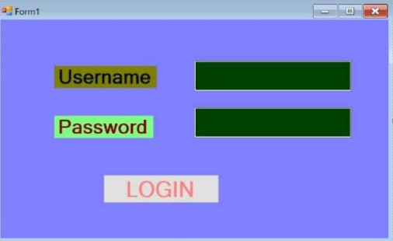

using System;

using System.Collections.Generic;

using System.ComponentModel;

using System.Data;

using System.Drawing;

using System.Linq;

using System.Text;

using System.Threading.Tasks;

using System.Windows.Forms;

namespace WindowsFormsApp7

{

public partial class Form1 : Form

{

public Form1()

{

InitializeComponent();

}

private void button1_Click(object sender, EventArgs e)

{

if (textBox1.Text == " ")

{

MessageBox.Show("Enter Username !!");

}

else if (textBox2.Text == " ")

{

MessageBox.Show("Enter Password !!");

}

else if (textBox1.Text == "cs " && textBox2.Text == "123")

{

this.Hide();

Form frm2 = new Form2();

frm2.ShowDialog();

}

else

{

MessageBox.Show("Invalid Credential", "Try Again");

}

}

}

}

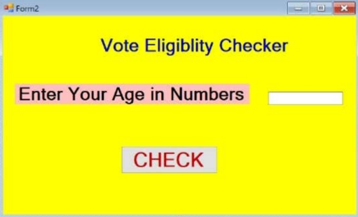

using System;

using System.Collections.Generic;

using System.ComponentModel;

using System.Data;

using System.Drawing;

using System.Linq;

using System.Text;

using System.Threading.Tasks;

using System.Windows.Forms;

namespace WindowsFormsApp7

{

public partial class Form2 : Form

{

public Form2()

{

InitializeComponent();

}

private void button1_Click(object sender, EventArgs e)

{

int a;

a = Convert.ToInt32(vote1.Text);

if (a <= 18)

{

MessageBox.Show("Eligibility To Vote!!");

}

else

{

MessageBox.Show("Not Eligibility To Vote !!");

}

}

}

}

OUTPUT:

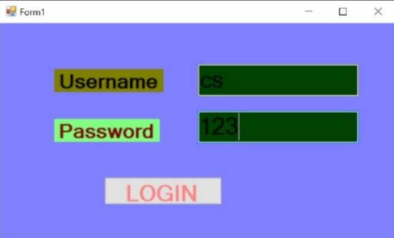

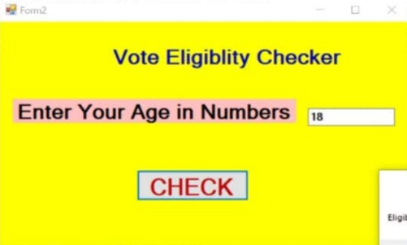

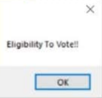

2. Exercise using validation class

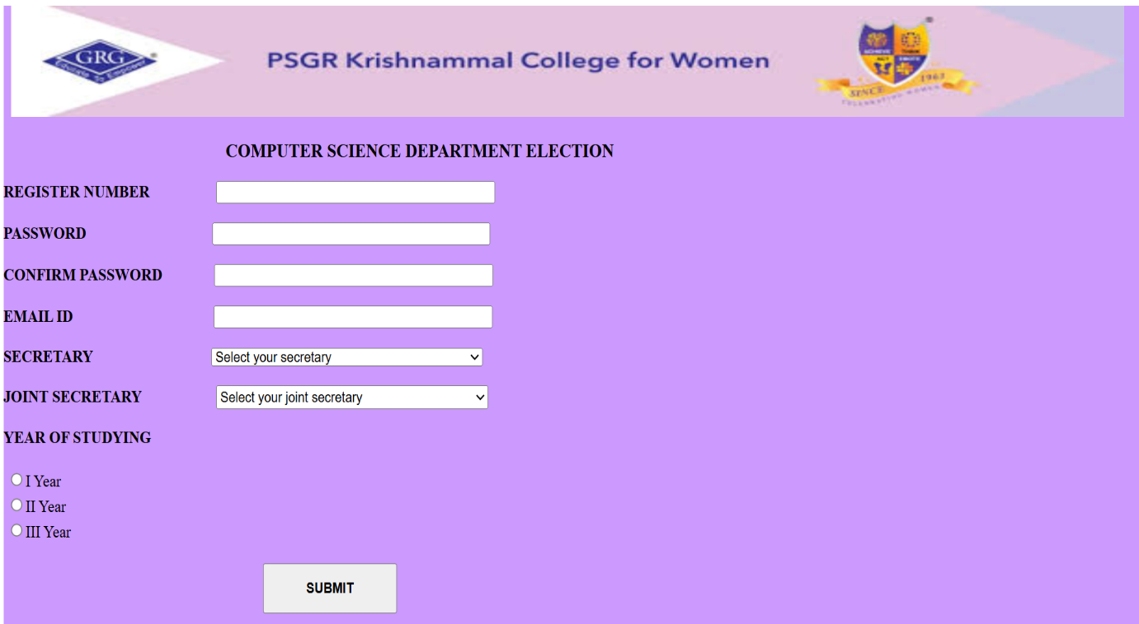

<!DOCTYPE html>

<html xmlns="http://www.w3.org/1999/xhtml">

<head runat="server">

<title></title>

</head>

<body>

<form id="form1" runat="server">

<div style="height: 1033px">

&nbsp;&nbsp;&nbsp;&nbsp;&nbsp;&nbsp;&nbsp;&nbsp;&nbsp;&nbsp;&nbsp;&nbsp;&nbsp;&nbsp;&nbsp;&nbsp;&nbsp;&nbsp;&nbsp;&nbsp;&nbsp;&nbsp;&nbsp;&nbsp;&nbsp;&nbsp;&nbsp;&nbsp;&nbsp;&nbsp;&nbsp;&nbsp;&nbsp;&nbsp;&nbsp;&nbsp;&nbsp;&nbsp;&nbsp;&nbsp;&nbsp;&nbsp;&nbsp;&nbsp;&nbsp;&nbsp;&nbsp;&nbsp;&nbsp;&nbsp;&nbsp;&nbsp;&nbsp;&nbsp;&nbsp;&nbsp;&nbsp;&nbsp;&nbsp;&nbsp;&nbsp;&nbsp;&nbsp;&nbsp;&nbsp;&nbsp;&nbsp;&nbsp;&nbsp;&nbsp;&nbsp;&nbsp;&nbsp;&nbsp;&nbsp;&nbsp;&nbsp;&nbsp;&nbsp;&nbsp;<br />

<br />

<br />

<br />

<br />

<br />

<br />

<br />

&nbsp;&nbsp;&nbsp;&nbsp;&nbsp;&nbsp;&nbsp;&nbsp;&nbsp;&nbsp;&nbsp;&nbsp;&nbsp;&nbsp;&nbsp;&nbsp;&nbsp;&nbsp;&nbsp;&nbsp;&nbsp;&nbsp;&nbsp;&nbsp;&nbsp;&nbsp;&nbsp;&nbsp;&nbsp;&nbsp;&nbsp;&nbsp;&nbsp;&nbsp;&nbsp;&nbsp;&nbsp;&nbsp;&nbsp;&nbsp;&nbsp;&nbsp;&nbsp;&nbsp;&nbsp;&nbsp;&nbsp;&nbsp;&nbsp;&nbsp;&nbsp;&nbsp;&nbsp;&nbsp;&nbsp;&nbsp;&nbsp;&nbsp;&nbsp;&nbsp;&nbsp;&nbsp;&nbsp;&nbsp;&nbsp;&nbsp;&nbsp;&nbsp;&nbsp;&nbsp;&nbsp;&nbsp;&nbsp;&nbsp;&nbsp;&nbsp;&nbsp;&nbsp;&nbsp;&nbsp;&nbsp;&nbsp;&nbsp;&nbsp;&nbsp;&nbsp;&nbsp; &nbsp;&nbsp;

<asp:Label ID="Label1" runat="server" Font-Bold="True" Text="COMPUTER SCIENCE DEPARTMENT ELECTION"></asp:Label>

<br />

<br />

&nbsp;<br />

<asp:Label ID="Label2" runat="server" Font-Bold="True" ForeColor="Black" Text="REGISTER NUMBER"></asp:Label>

&nbsp;&nbsp;&nbsp;&nbsp;&nbsp;&nbsp;&nbsp;&nbsp;&nbsp;&nbsp;&nbsp;&nbsp;&nbsp;

<asp:TextBox ID="TextBox1" runat="server" BorderColor="Black" Width="327px"></asp:TextBox>

&nbsp;&nbsp;

<asp:RequiredFieldValidator ID="RequiredFieldValidator1" runat="server" ControlToValidate="TextBox1" Display="Dynamic" ErrorMessage="Register number is mandatory" ForeColor="Red" SetFocusOnError="True">*</asp:RequiredFieldValidator>

<br />

<br />

<asp:Label ID="Label3" runat="server" Font-Bold="True" Text="PASSWORD"></asp:Label>

&nbsp;&nbsp;&nbsp;&nbsp;&nbsp;&nbsp;&nbsp;&nbsp;&nbsp;&nbsp;&nbsp;&nbsp;&nbsp;&nbsp;&nbsp;&nbsp;&nbsp;&nbsp;&nbsp;&nbsp;&nbsp;&nbsp;&nbsp;&nbsp;&nbsp;&nbsp;&nbsp;&nbsp;&nbsp;

<asp:TextBox ID="TextBox2" runat="server" BorderColor="Black" Width="327px"></asp:TextBox>

&nbsp;

<br />

<br />

<asp:Label ID="Label4" runat="server" Font-Bold="True" Text="CONFIRM PASSWORD"></asp:Label>

&nbsp;&nbsp;&nbsp;&nbsp;&nbsp;&nbsp;&nbsp;&nbsp;&nbsp;

<asp:TextBox ID="TextBox3" runat="server" BorderColor="Black" Width="329px"></asp:TextBox>

&nbsp;

<asp:CompareValidator ID="CompareValidator1" runat="server" ControlToCompare="TextBox2" ControlToValidate="TextBox3" Display="Dynamic" ErrorMessage="Password and confirm password" ForeColor="#FF3300" SetFocusOnError="True">Password Mismatach</asp:CompareValidator>

<br />

<br />

<asp:Label ID="Label5" runat="server" Font-Bold="True" Text="EMAIL ID"></asp:Label>

&nbsp;&nbsp;&nbsp;&nbsp;&nbsp;&nbsp;&nbsp;&nbsp;&nbsp;&nbsp;&nbsp;&nbsp;&nbsp;&nbsp;&nbsp;&nbsp;&nbsp;&nbsp;&nbsp;&nbsp;&nbsp;&nbsp;&nbsp;&nbsp;&nbsp;&nbsp;&nbsp;&nbsp;&nbsp;&nbsp;&nbsp;&nbsp;

<asp:TextBox ID="TextBox4" runat="server" BorderColor="Black" Width="330px"></asp:TextBox>

&nbsp;

<asp:RegularExpressionValidator ID="RegularExpressionValidator1" runat="server" ControlToValidate="TextBox4" Display="Dynamic" ErrorMessage="email is in incorrect format" ForeColor="#FF3300" SetFocusOnError="True" ValidationExpression="\w+([-+.']\w+)*@\w+([-.]\w+)*\.\w+([-.]\w+)*">Invalid Email</asp:RegularExpressionValidator>

<br />

<br />

<asp:Label ID="Label6" runat="server" Font-Bold="True" Text="SECRETARY"></asp:Label>

&nbsp;&nbsp;&nbsp;&nbsp;&nbsp;&nbsp;&nbsp;&nbsp;&nbsp;&nbsp;&nbsp;&nbsp;&nbsp;&nbsp;&nbsp;&nbsp;&nbsp;&nbsp;&nbsp;&nbsp;&nbsp;&nbsp;&nbsp;&nbsp;&nbsp;&nbsp;

<asp:DropDownList ID="DropDownList1" runat="server" Height="16px" Width="335px">

<asp:ListItem>Select Your Secretary</asp:ListItem>

<asp:ListItem>Kaviya</asp:ListItem>

<asp:ListItem>Mughila</asp:ListItem>

</asp:DropDownList>

&nbsp;

<asp:RequiredFieldValidator ID="RequiredFieldValidator2" runat="server" ControlToValidate="DropDownList1" Display="Dynamic" ErrorMessage="RequiredFieldValidator" ForeColor="#FF3300" InitialValue="Select Your Secretary" SetFocusOnError="True">*</asp:RequiredFieldValidator>

<br />

<br />

<asp:Label ID="Label7" runat="server" Font-Bold="True" Text="JOINT SECRETARY"></asp:Label>

&nbsp;&nbsp;&nbsp;&nbsp;&nbsp;&nbsp;&nbsp;&nbsp;&nbsp;&nbsp;&nbsp;&nbsp;&nbsp;

<asp:DropDownList ID="DropDownList2" runat="server" Height="16px" Width="329px">

<asp:ListItem>Select Your Joint Secretary</asp:ListItem>

<asp:ListItem>Anisha</asp:ListItem>

<asp:ListItem>Priya</asp:ListItem>

</asp:DropDownList>

&nbsp;&nbsp;

<asp:RequiredFieldValidator ID="RequiredFieldValidator3" runat="server" ControlToValidate="DropDownList2" Display="Dynamic" ErrorMessage="RequiredFieldValidator" ForeColor="#FF3300" InitialValue="Select Your Joint secretary" SetFocusOnError="True">*</asp:RequiredFieldValidator>

<br />

<br />

<asp:Label ID="Label8" runat="server" Font-Bold="True" Text="YEAR OF STUDYING"></asp:Label>

&nbsp;&nbsp;&nbsp;&nbsp;&nbsp;&nbsp;&nbsp;&nbsp;&nbsp;&nbsp;&nbsp;

<br />

<asp:RadioButtonList ID="RadioButtonList1" runat="server" Font-Bold="True">

<asp:ListItem>I Year</asp:ListItem>

<asp:ListItem>II Year</asp:ListItem>

<asp:ListItem>III Year</asp:ListItem>

</asp:RadioButtonList>

<asp:RequiredFieldValidator ID="RequiredFieldValidator4" runat="server" ControlToValidate="RadioButtonList1" Display="Dynamic" ErrorMessage="Should select" ForeColor="#FF3300" SetFocusOnError="True">*</asp:RequiredFieldValidator>

<br />

<br />

&nbsp;&nbsp;&nbsp;&nbsp;&nbsp;&nbsp;&nbsp;&nbsp;&nbsp;&nbsp;&nbsp;&nbsp;&nbsp;&nbsp;&nbsp;&nbsp;&nbsp;&nbsp;&nbsp;&nbsp;&nbsp;&nbsp;&nbsp;&nbsp;&nbsp;&nbsp;&nbsp;&nbsp;&nbsp;&nbsp;&nbsp;&nbsp;&nbsp;&nbsp;&nbsp;&nbsp;&nbsp;&nbsp;&nbsp;&nbsp;&nbsp;&nbsp;&nbsp;&nbsp;&nbsp;&nbsp;&nbsp;&nbsp;&nbsp;&nbsp;&nbsp;&nbsp;&nbsp;&nbsp;&nbsp;&nbsp;&nbsp;&nbsp;&nbsp;&nbsp;&nbsp;&nbsp;&nbsp;&nbsp;&nbsp;&nbsp;&nbsp;&nbsp;&nbsp;&nbsp;

<asp:Button ID="Button1" runat="server" Font-Bold="True" Height="44px" OnClick="Button1_Click" Text="Submit" Width="105px" />

<br />

<br />

&nbsp;

<br />

&nbsp;&nbsp;&nbsp;&nbsp;

&nbsp;&nbsp;&nbsp;&nbsp;&nbsp;&nbsp;&nbsp;&nbsp;&nbsp;&nbsp;&nbsp;&nbsp;&nbsp;&nbsp;

&nbsp;&nbsp;&nbsp;&nbsp;&nbsp;&nbsp;&nbsp;&nbsp;&nbsp;&nbsp;&nbsp;&nbsp;&nbsp;&nbsp;&nbsp;&nbsp;&nbsp;&nbsp;&nbsp;&nbsp;&nbsp;&nbsp;&nbsp;&nbsp;&nbsp;&nbsp;&nbsp;&nbsp;&nbsp;&nbsp;&nbsp;&nbsp;&nbsp;&nbsp;&nbsp;&nbsp;&nbsp;&nbsp;&nbsp;&nbsp;&nbsp;&nbsp;&nbsp;&nbsp;&nbsp;&nbsp;&nbsp;&nbsp;&nbsp;&nbsp;&nbsp;&nbsp;&nbsp;&nbsp;&nbsp;&nbsp;

&nbsp;&nbsp;&nbsp;&nbsp;&nbsp;&nbsp;&nbsp;&nbsp;&nbsp;&nbsp;&nbsp;&nbsp;&nbsp;&nbsp;&nbsp;&nbsp;&nbsp;&nbsp;&nbsp;&nbsp;&nbsp;&nbsp;&nbsp;&nbsp;&nbsp;&nbsp;&nbsp;&nbsp;&nbsp;&nbsp;&nbsp;&nbsp;&nbsp;&nbsp;&nbsp;&nbsp;&nbsp;&nbsp;&nbsp;&nbsp;&nbsp;&nbsp;&nbsp;&nbsp;&nbsp;&nbsp;&nbsp;&nbsp;&nbsp;&nbsp;&nbsp;&nbsp;&nbsp;&nbsp;&nbsp;&nbsp;&nbsp;&nbsp;&nbsp;&nbsp;&nbsp;&nbsp;&nbsp;&nbsp;&nbsp;&nbsp;&nbsp;&nbsp;&nbsp;&nbsp;&nbsp;&nbsp;&nbsp;&nbsp;&nbsp;&nbsp;&nbsp;&nbsp;&nbsp;&nbsp;&nbsp;&nbsp;&nbsp;&nbsp;&nbsp;&nbsp;&nbsp;&nbsp;

<br />

&nbsp;

<br />

&nbsp;&nbsp;&nbsp;&nbsp;

&nbsp;&nbsp;&nbsp;&nbsp;&nbsp;&nbsp;&nbsp;&nbsp;&nbsp;&nbsp;&nbsp;&nbsp;&nbsp;&nbsp;&nbsp;&nbsp;&nbsp;&nbsp;&nbsp;&nbsp;&nbsp;&nbsp;&nbsp;&nbsp;&nbsp;&nbsp;&nbsp;&nbsp;&nbsp;&nbsp;&nbsp;&nbsp;&nbsp;&nbsp;&nbsp;&nbsp;&nbsp;&nbsp;&nbsp;&nbsp;&nbsp;&nbsp;&nbsp;&nbsp;&nbsp;&nbsp;&nbsp;&nbsp;&nbsp;&nbsp;&nbsp;&nbsp;&nbsp;&nbsp;&nbsp;&nbsp;&nbsp;&nbsp;&nbsp;&nbsp;&nbsp;&nbsp;&nbsp;&nbsp;&nbsp;&nbsp;&nbsp;&nbsp;&nbsp;&nbsp;&nbsp;&nbsp;&nbsp;&nbsp;&nbsp;&nbsp;&nbsp;&nbsp;&nbsp;&nbsp;&nbsp;&nbsp;&nbsp;&nbsp;&nbsp;&nbsp;&nbsp;&nbsp;&nbsp;&nbsp;&nbsp;&nbsp;&nbsp;&nbsp;&nbsp;&nbsp;&nbsp;&nbsp;&nbsp;&nbsp;&nbsp;&nbsp;&nbsp;&nbsp;&nbsp;&nbsp;&nbsp;&nbsp;&nbsp;&nbsp;&nbsp;&nbsp;&nbsp;&nbsp;&nbsp;&nbsp;

&nbsp;&nbsp;

<br />

&nbsp;&nbsp;&nbsp;&nbsp;

&nbsp;&nbsp;&nbsp;&nbsp;&nbsp;&nbsp;&nbsp;&nbsp;&nbsp;&nbsp;&nbsp;&nbsp;&nbsp;&nbsp;&nbsp;&nbsp;&nbsp;&nbsp;&nbsp;&nbsp;

&nbsp;&nbsp;&nbsp;&nbsp;&nbsp;&nbsp;&nbsp;&nbsp;&nbsp;&nbsp;&nbsp;&nbsp;&nbsp;&nbsp;&nbsp;&nbsp;&nbsp;&nbsp;&nbsp;&nbsp;&nbsp;&nbsp;&nbsp;&nbsp;&nbsp;&nbsp;&nbsp;&nbsp;&nbsp;&nbsp;&nbsp;&nbsp;&nbsp;&nbsp;&nbsp;&nbsp;&nbsp;&nbsp;&nbsp;&nbsp;&nbsp;&nbsp;&nbsp;&nbsp;&nbsp;&nbsp;&nbsp;&nbsp;&nbsp;&nbsp;&nbsp;&nbsp;&nbsp;&nbsp;&nbsp;&nbsp;&nbsp;&nbsp;

&nbsp;&nbsp;&nbsp;&nbsp;&nbsp;&nbsp;&nbsp;&nbsp;&nbsp;&nbsp;&nbsp;&nbsp;&nbsp;&nbsp;&nbsp;&nbsp;&nbsp;&nbsp;&nbsp;&nbsp;&nbsp;&nbsp;&nbsp;&nbsp;&nbsp;&nbsp;&nbsp;&nbsp;&nbsp;&nbsp;&nbsp;&nbsp;&nbsp;&nbsp;&nbsp;&nbsp;&nbsp;&nbsp;&nbsp;&nbsp;&nbsp;&nbsp;&nbsp;&nbsp;&nbsp;&nbsp;&nbsp;&nbsp;&nbsp;&nbsp;&nbsp;&nbsp;&nbsp;&nbsp;&nbsp;&nbsp;&nbsp;&nbsp;

<br />

<br />

&nbsp;&nbsp;&nbsp;&nbsp;

&nbsp;&nbsp;&nbsp;&nbsp;&nbsp;&nbsp;&nbsp;&nbsp;&nbsp;&nbsp;&nbsp;&nbsp;&nbsp;&nbsp;&nbsp;&nbsp;&nbsp;&nbsp;&nbsp;

&nbsp;&nbsp;&nbsp;&nbsp;&nbsp;&nbsp;&nbsp;&nbsp;&nbsp;&nbsp;&nbsp;&nbsp;&nbsp;&nbsp;&nbsp;&nbsp;&nbsp;&nbsp;&nbsp;&nbsp;&nbsp;&nbsp;&nbsp;&nbsp;&nbsp;&nbsp;&nbsp;&nbsp;&nbsp;&nbsp;&nbsp;&nbsp;&nbsp;&nbsp;&nbsp;&nbsp;&nbsp;&nbsp;&nbsp;&nbsp;&nbsp;&nbsp;&nbsp;&nbsp;&nbsp;&nbsp;&nbsp;&nbsp;&nbsp;&nbsp;&nbsp;&nbsp;&nbsp;&nbsp;&nbsp;&nbsp;&nbsp;&nbsp;

&nbsp;

<br />

&nbsp;&nbsp;&nbsp;&nbsp;&nbsp;&nbsp;&nbsp;&nbsp;&nbsp;&nbsp;&nbsp;&nbsp;&nbsp;&nbsp;&nbsp;&nbsp;&nbsp;&nbsp;&nbsp;&nbsp;&nbsp;&nbsp;&nbsp;&nbsp;&nbsp;&nbsp;&nbsp;&nbsp;&nbsp;&nbsp;&nbsp;&nbsp;&nbsp;&nbsp;&nbsp;&nbsp;&nbsp;&nbsp;&nbsp;&nbsp;&nbsp;&nbsp;&nbsp;&nbsp;&nbsp;&nbsp;&nbsp;&nbsp;&nbsp;&nbsp;&nbsp;&nbsp;&nbsp;&nbsp;&nbsp;&nbsp;&nbsp;&nbsp;&nbsp;&nbsp;&nbsp;&nbsp;&nbsp;&nbsp;&nbsp;&nbsp;&nbsp;&nbsp;&nbsp;&nbsp;&nbsp;&nbsp;&nbsp;&nbsp;&nbsp;&nbsp;&nbsp;&nbsp;&nbsp;&nbsp;&nbsp;&nbsp;&nbsp;&nbsp;&nbsp;

<br />

<br />

&nbsp;&nbsp;&nbsp;&nbsp;

&nbsp;&nbsp;&nbsp;&nbsp;&nbsp;&nbsp;&nbsp;&nbsp;&nbsp;&nbsp;

<br />

<br />

&nbsp;&nbsp;&nbsp;&nbsp;&nbsp;&nbsp;&nbsp;&nbsp;&nbsp;&nbsp;&nbsp;&nbsp;&nbsp;&nbsp;&nbsp;&nbsp;&nbsp;&nbsp;

<br />

<br />

&nbsp;&nbsp;&nbsp;&nbsp;&nbsp;

</div>

</form>

</body>

</html>

using System;

using System.Collections.Generic;

using System.Linq;

using System.Web;

using System.Web.UI;

using System.Web.UI.WebControls;

namespace WebApplication13

{

public partial class WebForm1 : System.Web.UI.Page

{

protected void Page_Load(object sender, EventArgs e)

{

}

protected void Button1_Click(object sender, EventArgs e)

{

if (Page.IsValid)

{

L1.Text = "Thank You" ;

}

else

{

L1.Text = "Fill up all the fields ";

}

}

}

}

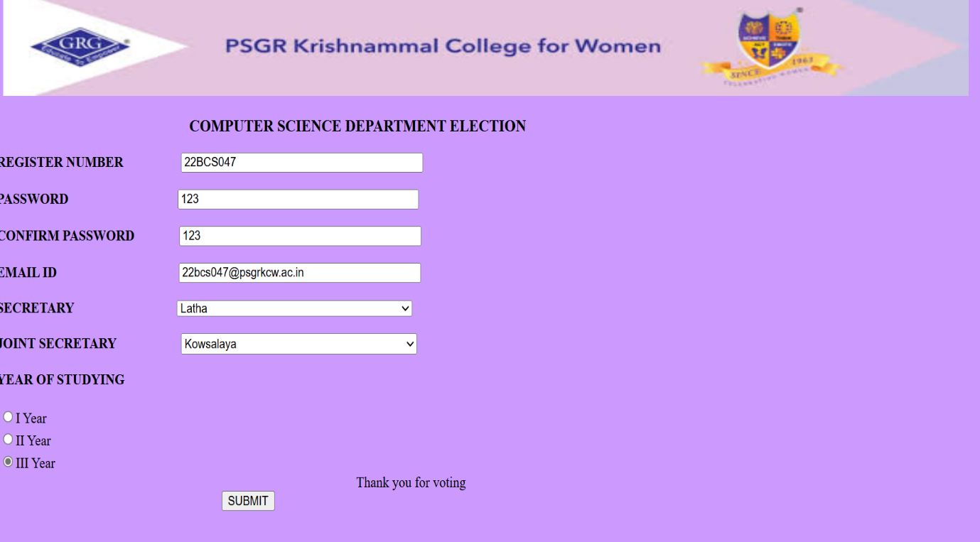

3. Exercise using iterative structures

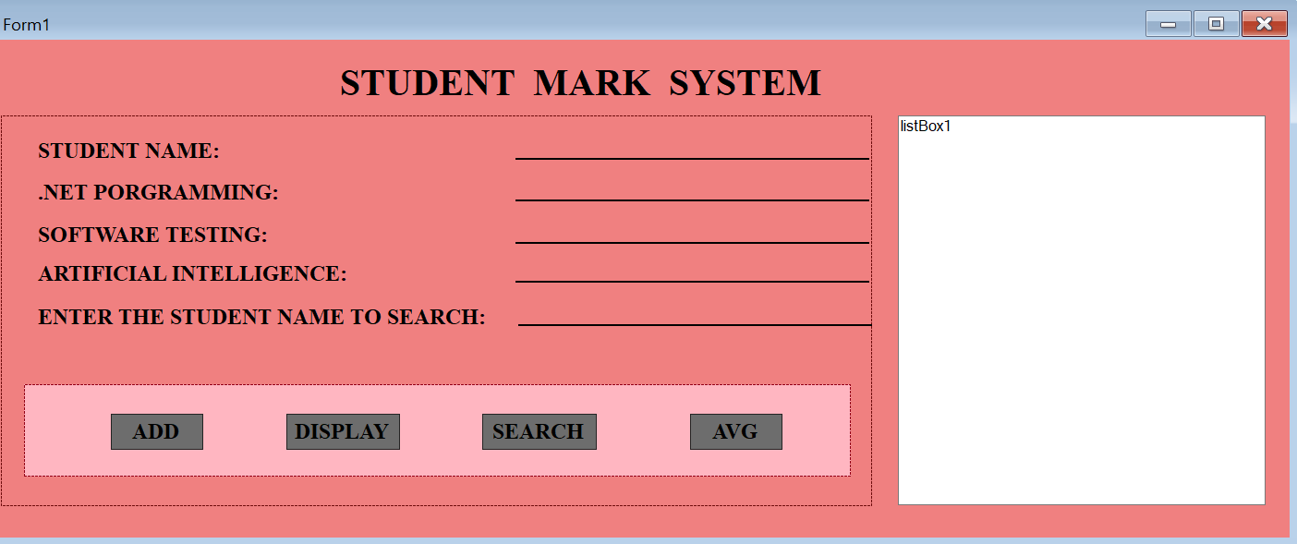

using System;

using System.Collections.Generic;

using System.ComponentModel;

using System.Data;

using System.Drawing;

using System.Linq;

using System.Text;

using System.Threading.Tasks;

using System.Windows.Forms;

namespace WindowsFormsApp8

{

public partial class Form1 : Form

{

string[] StudentNames = new string[100];

int[,] StudentMarks = new int[100, 3];

int studentcount = 0;

public Form1()

{

InitializeComponent();

}

private void add_Click(object sender, EventArgs e)

{

if (studentcount >= 100)

{

MessageBox.Show("student list full");

}

StudentNames[studentcount] = textBox1.Text;

StudentMarks[studentcount, 0] = Convert.ToInt32(textBox2.Text);

StudentMarks[studentcount, 1] = Convert.ToInt32(textBox3.Text);

StudentMarks[studentcount, 2] = Convert.ToInt32(textBox4.Text);

studentcount++;

MessageBox.Show("student added successfully");

ClearInputs();

}

private void display_Click(object sender, EventArgs e)

{

listBox1.Items.Clear();

for (int i = 0; i < studentcount; i++)

{

listBox1.Items.Add($"{ StudentNames[i]}-Marks:{StudentMarks[i,0]},{ StudentMarks[i, 1]},{ StudentMarks[i, 2]}");

}

}

private void avg_Click(object sender, EventArgs e)

{

if (studentcount == 0)

{

MessageBox.Show(" No students available ");

return;

}

double totalmarks = 0;

int totalsubjets = studentcount * 3;

for (int i = 0; i < studentcount; i++)

{

for (int j = 0; j < 3; j++)

{

totalmarks += StudentMarks[i, j];

}

}

double average = totalmarks / totalsubjets;

MessageBox.Show($"class Average Marks: {average:F2}");

}

private void search_Click(object sender, EventArgs e)

{

string searchname = textBox5.Text;

bool found = false;

for (int i = 0; i < studentcount; i++)

{

if (StudentNames[i].Equals(searchname,

StringComparison.OrdinalIgnoreCase))

{

MessageBox.Show($" student found:{ StudentNames[i]}marks:{ StudentMarks[i, 0]},{ StudentMarks[i, 1]},{ StudentMarks[i, 2]}");

found = true;

break;

}

}

if (!found)

{

MessageBox.Show("student not found.");

}

}

private void ClearInputs()

{

textBox1.Clear();

textBox2.Clear();

textBox3.Clear();

textBox4.Clear();

}

}

}

OUTPUT:

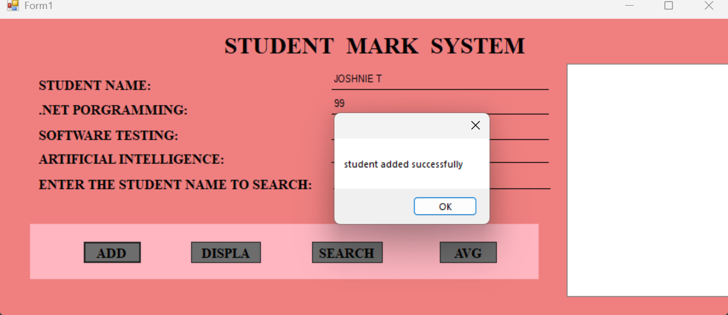

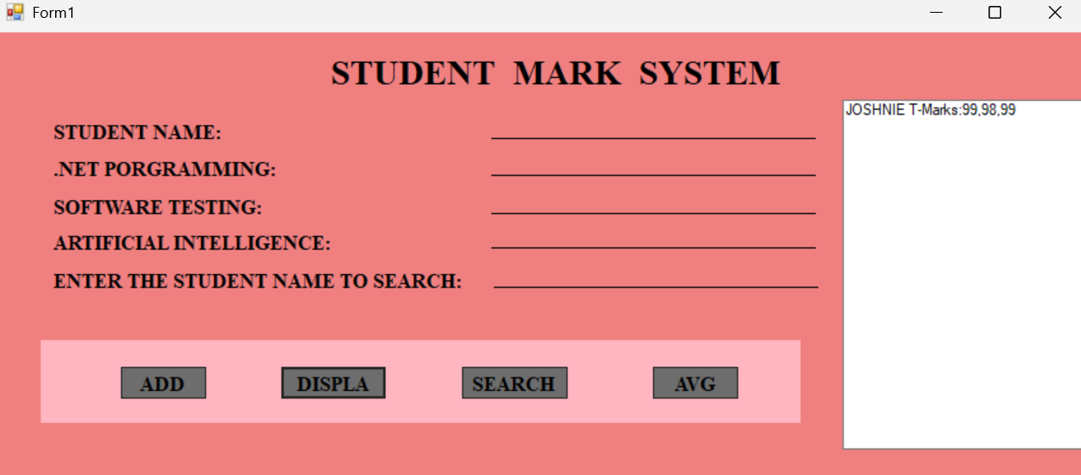

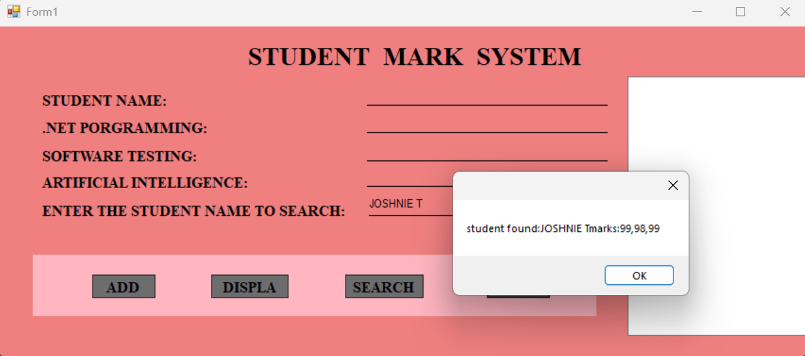

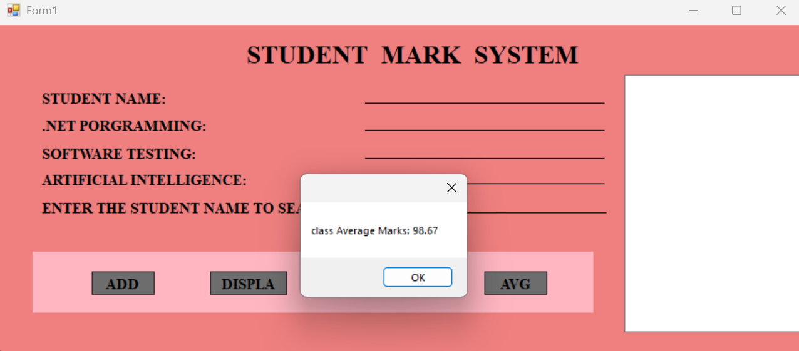

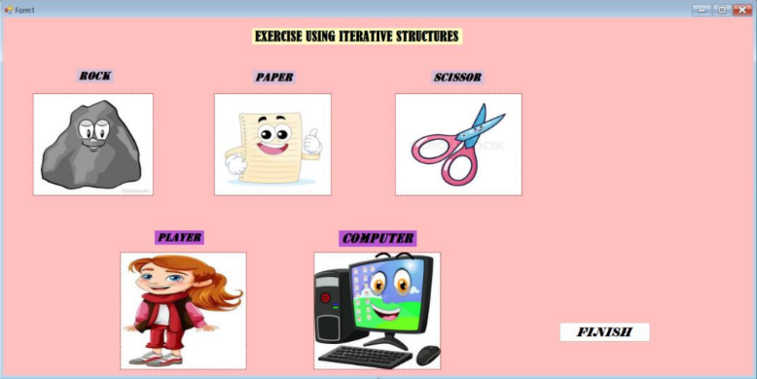

PROGRAM:

using System;

using System.Collections.Generic;

using System.ComponentModel;

using System.Data;

using System.Drawing;

using System.Linq;

using System.Text;

using System.Threading.Tasks;

using System.Windows.Forms;

namespace WindowsFormsApp9

{

public partial class Form1 : Form

{

public Form1()

{

InitializeComponent();

}

private void button2_Click(object sender, EventArgs e)

{

this.Close();

}

private void rock_Click(object sender, EventArgs e)

{

Random randomGenerator = new Random();

int computerChoice;

player.BackgroundImage = rock.BackgroundImage;

computerChoice = randomGenerator.Next(1, 4);

switch (computerChoice)

{

case 1:

computer.BackgroundImage = rock.BackgroundImage;

winnerLabel.Text = "TIE " ;

break;

case 2:

computer.BackgroundImage = paper.BackgroundImage;

winnerLabel.Text = "Computer wins because paper covers rock " ;

break;

case 3:

computer.BackgroundImage = scissor.BackgroundImage;

winnerLabel.Text = "Player wins because rock breaks scissors " ;

break;

}

}

private void paper_Click(object sender, EventArgs e)

{

Random randomGenerator = new Random();

int computerChoice;

player.BackgroundImage = paper.BackgroundImage;

computerChoice = randomGenerator.Next(1, 4);

switch (computerChoice)

{

case 1:

computer.BackgroundImage = rock.BackgroundImage;

winnerLabel.Text = "Payer wins because paper covers rock " ;

break;

case 2:

computer.BackgroundImage = paper.BackgroundImage;

winnerLabel.Text = " TIE " ;

break;

case 3:

computer.BackgroundImage = scissor.BackgroundImage;

winnerLabel.Text = "Computer wins because scissors cut paper " ;

break;

}

}

private void scissor_Click(object sender, EventArgs e)

{

Random randomGenerator = new Random();

int computerChoice;

player.BackgroundImage = scissor.BackgroundImage;

computerChoice = randomGenerator.Next(1, 4);

switch (computerChoice)

{

case 1:

computer.BackgroundImage = rock.BackgroundImage;

winnerLabel.Text = "Computer wins because rock breaks scissors " ;

break;

case 2:

computer.BackgroundImage = paper.BackgroundImage;

winnerLabel.Text = "Player wins because scissors cut paper " ;

break;

case 3:

computer.BackgroundImage = scissor.BackgroundImage;

winnerLabel.Text = "TIE ";

break;

}

}

}

}

OUTPUT:

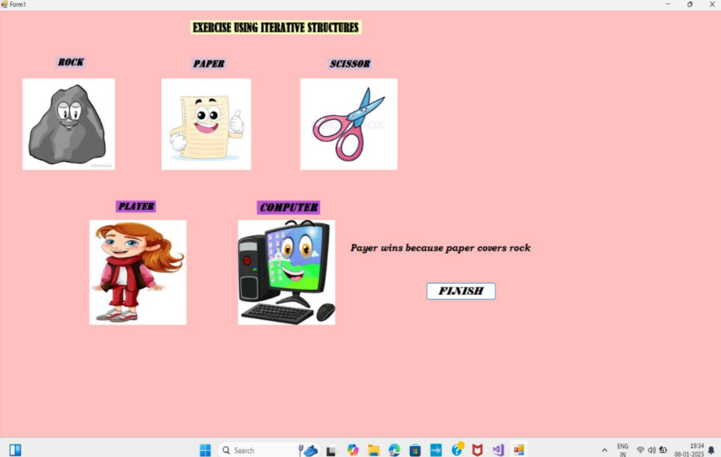

4. Exercise using basic control classes

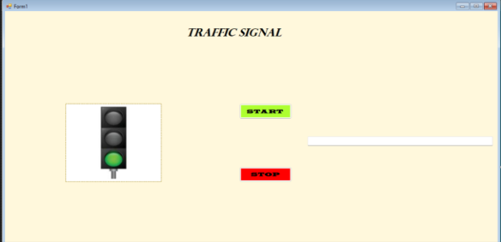

using System;

using System.Collections.Generic;

using System.ComponentModel;

using System.Data;

using System.Drawing;

using System.Linq;

using System.Text;

using System.Threading.Tasks;

using System.Windows.Forms;

namespace trafficlight

{

public partial class Form1 : Form

{

public Form1()

{

InitializeComponent();

red.Visible = true;

yellow.Visible = false;

green.Visible = false;

}

private void timer1_Tick(object sender, EventArgs e)

{

if (red.Visible == true)

{

red.Visible = false;

yellow.Visible = false;

green.Visible = true;

textBox1.Text = "Have a safe journey";

timerred.Enabled = true;

}

else if(green.Visible == true)

{

red.Visible = false;

yellow.Visible = true;

green.Visible = false;

textBox1.Text = "slow down your vehicle";

timeryellow.Enabled = true;

}

else if(yellow.Visible == true)

{

red.Visible = true;

yellow.Visible = false;

green.Visible = false;

timergreen.Enabled = true;

textBox1.Text = "stop your vehicle";

}

}

private void start_Click(object sender, EventArgs e)

{

timerred.Enabled = true;

}

private void stop_Click(object sender, EventArgs e)

{

timerred.Enabled = false;

}

}

}

OUTPUT:

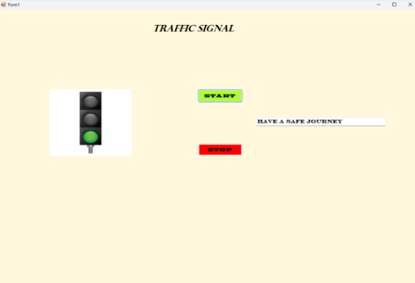

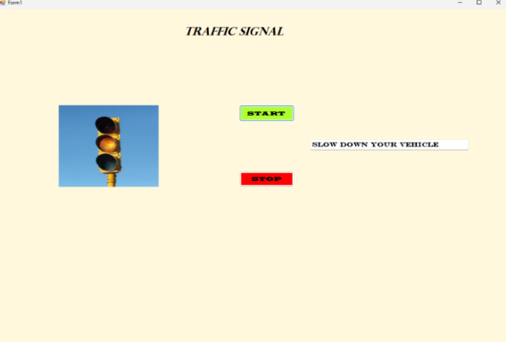

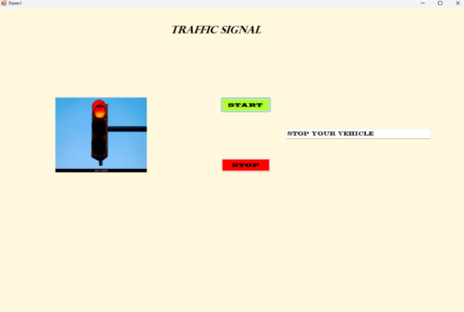

4. Exercise using Sitemap classes

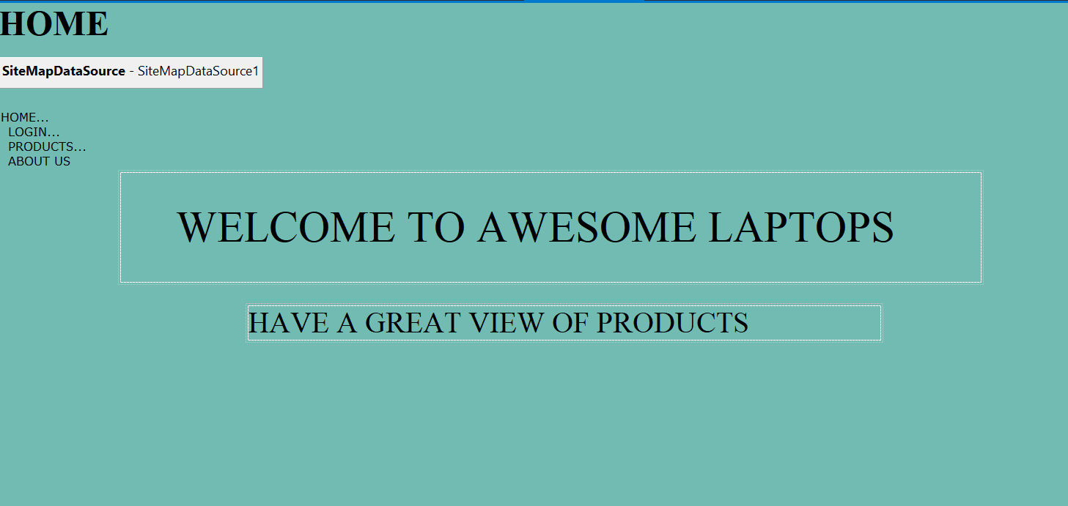

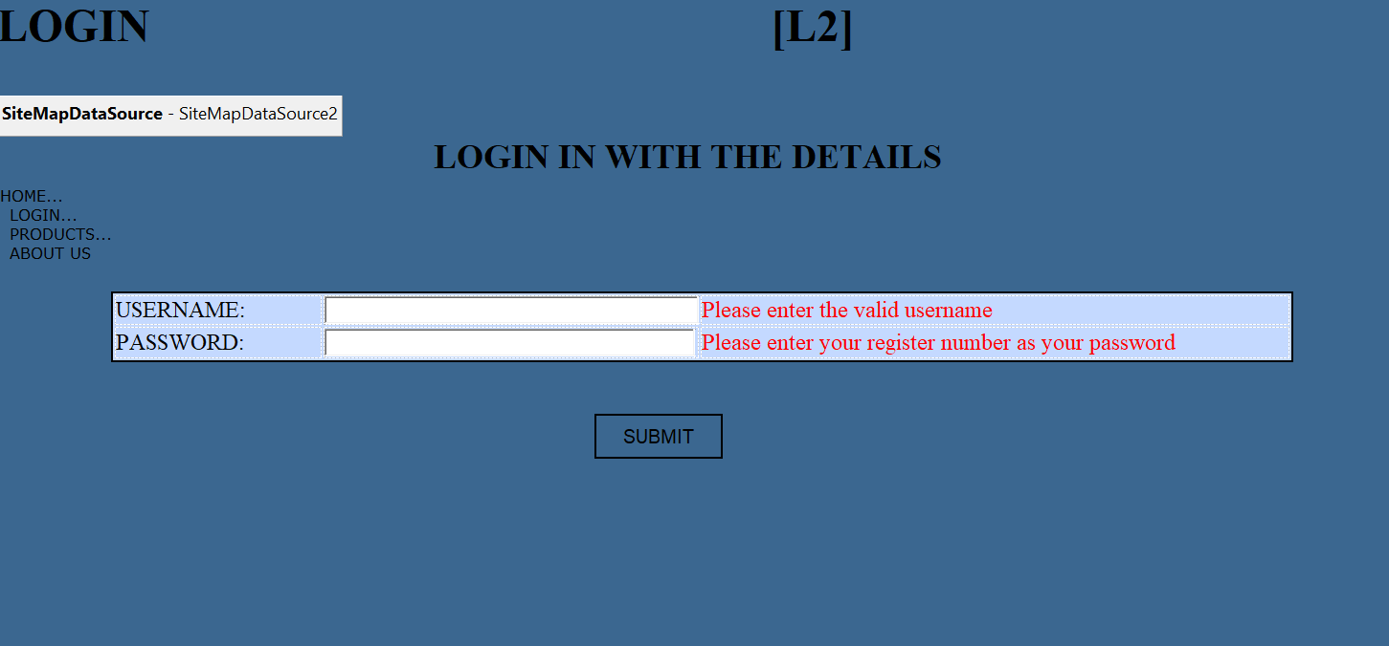

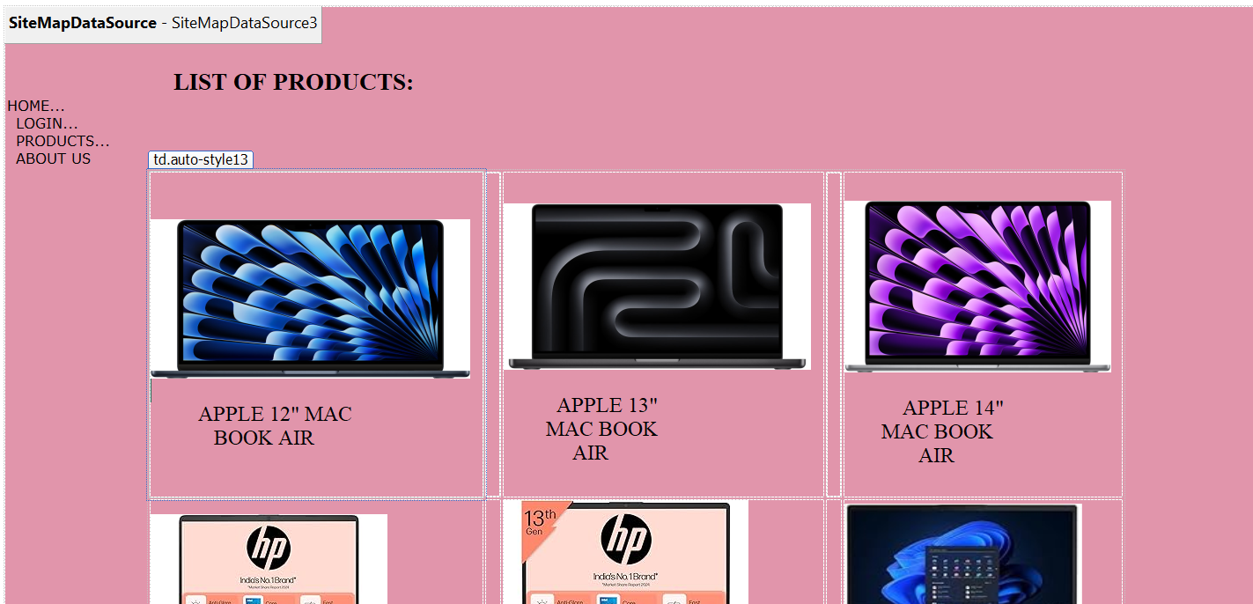

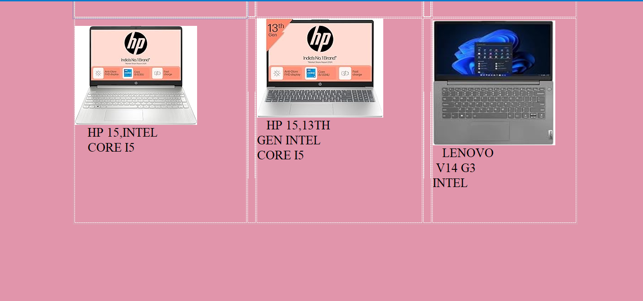

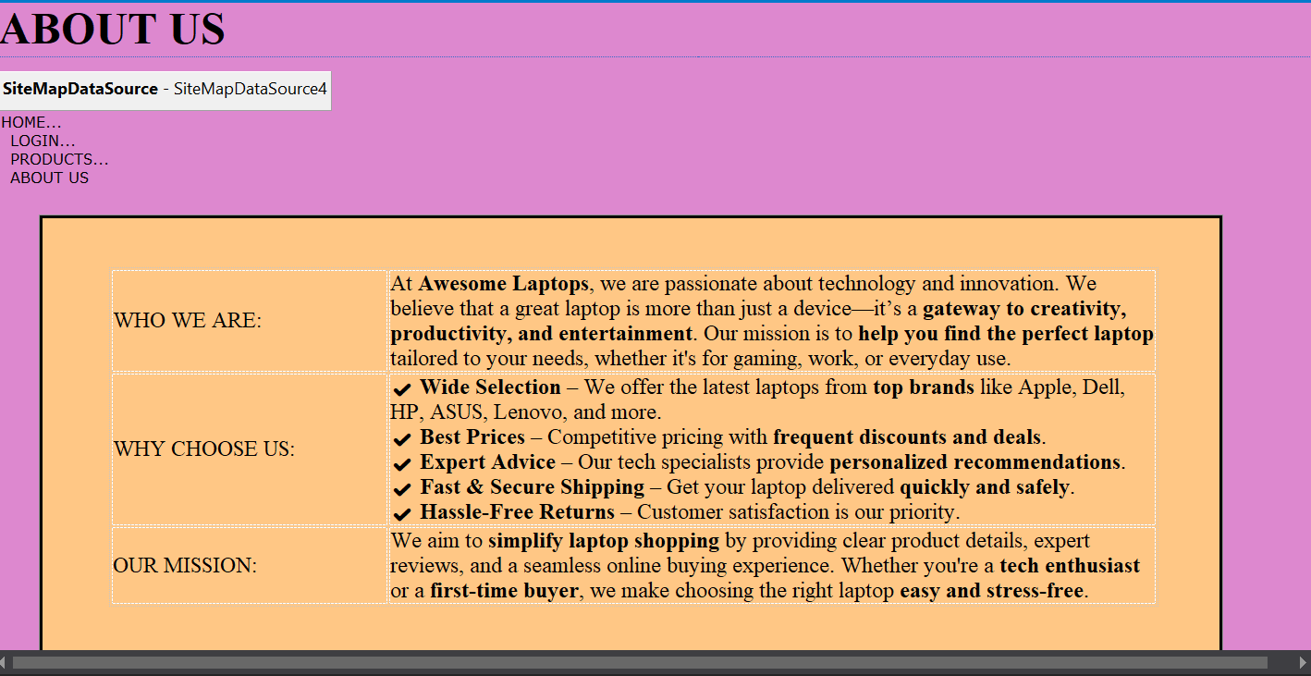

PROGRAM:

Web.sitemap:

<?xml version="1.0" encoding="utf-8" ?>

<siteMap xmlns="http://schemas.microsoft.com/AspNet/SiteMap-File-1.0" >

<siteMapNode url="Home.aspx" title="HOME..." description="">

<siteMapNode url="Login.aspx" title="LOGIN..." description="" />

<siteMapNode url="Products.aspx" title="PRODUCTS..." description="" />

<siteMapNode url="About us.aspx" title="ABOUT US" description=""/>

</siteMapNode>

</siteMap>

Web.config:

<?xml version="1.0" encoding="utf-8"?>

<!--

For more information on how to configure your ASP.NET application, please visit

https://go.microsoft.com/fwlink/?LinkId=169433

-->

<configuration>

<appSettings>

<add key="ValidationSettings:UnobtrusiveValidationMode" value="None"></add>

</appSettings>

<system.web>

<compilation debug="true" targetFramework="4.7.2" />

<httpRuntime targetFramework="4.7.2" />

</system.web>

<system.codedom>

<compilers>

<compiler language="c#;cs;csharp" extension=".cs" type="Microsoft.CodeDom.Providers.DotNetCompilerPlatform.CSharpCodeProvider, Microsoft.CodeDom.Providers.DotNetCompilerPlatform, Version=2.0.1.0, Culture=neutral, PublicKeyToken=31bf3856ad364e35" warningLevel="4" compilerOptions="/langversion:default /nowarn:1659;1699;1701" />

<compiler language="vb;vbs;visualbasic;vbscript" extension=".vb" type="Microsoft.CodeDom.Providers.DotNetCompilerPlatform.VBCodeProvider, Microsoft.CodeDom.Providers.DotNetCompilerPlatform, Version=2.0.1.0, Culture=neutral, PublicKeyToken=31bf3856ad364e35" warningLevel="4" compilerOptions="/langversion:default /nowarn:41008 /define:_MYTYPE=\&quot;Web\&quot; /optionInfer+" />

</compilers>

</system.codedom>

</configuration>

using System;

using System.Collections.Generic;

using System.Linq;

using System.Web;

using System.Web.UI;

using System.Web.UI.WebControls;

using System.Text.RegularExpressions;

namespace Sitemap_Navigation_project

{

public partial class Login : System.Web.UI.Page

{

protected void Page_Load(object sender, EventArgs e)

{

}

protected void button1_Click(object sender, EventArgs e)

{

string username = TextBox1.Text;

string password = TextBox2.Text;

if (Page.IsValid)

{

Response.Redirect("Products.aspx");

}

else

{

L2.Text = "Invalid Username or Password!";

L2.ForeColor = System.Drawing.Color.Red;

}

}

}

}

OUTPUT:

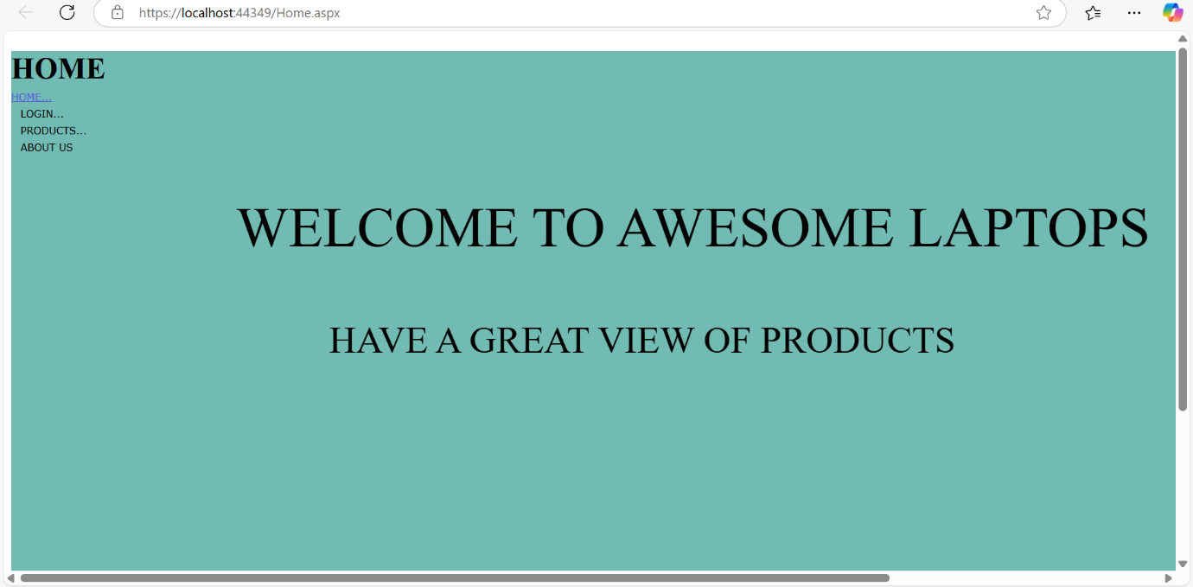

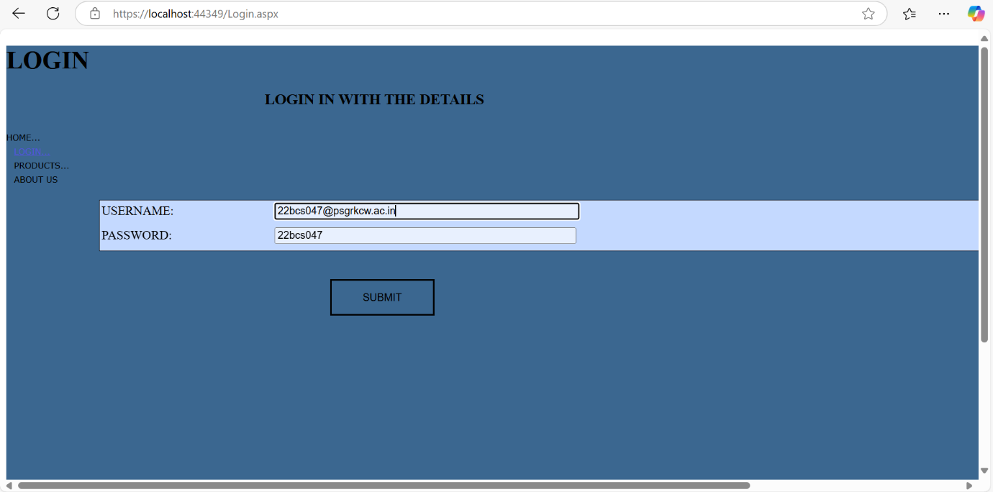

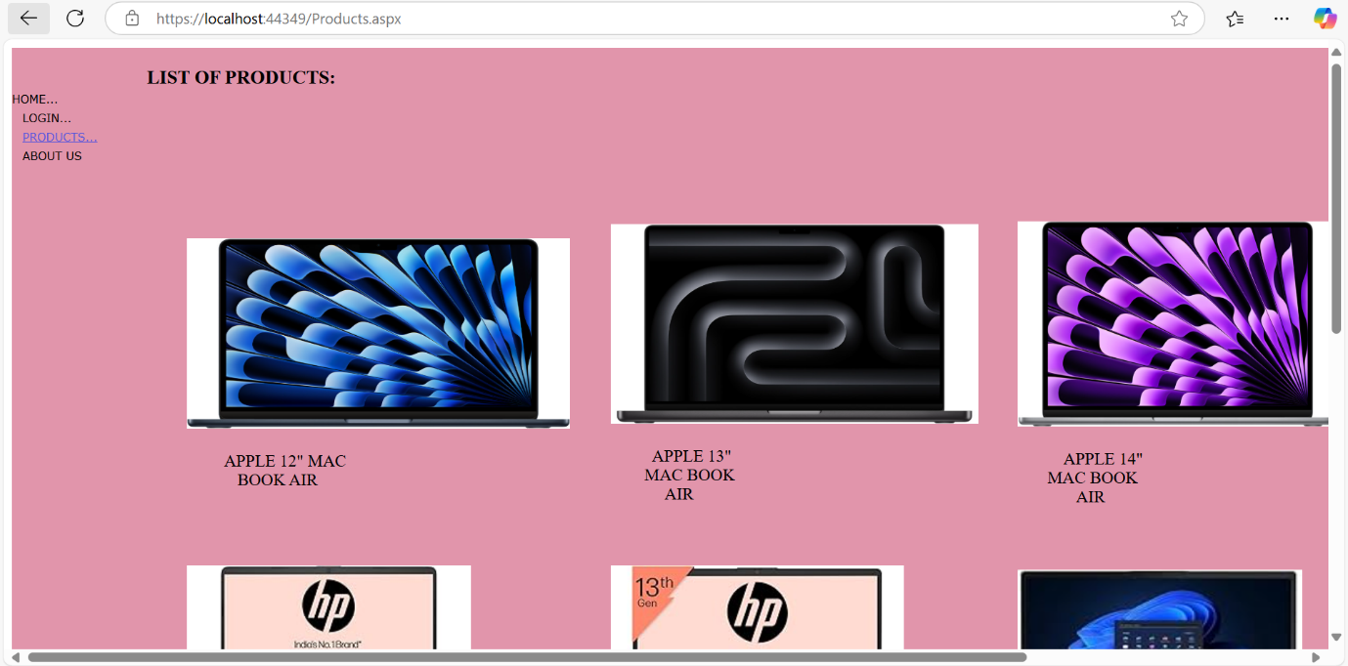

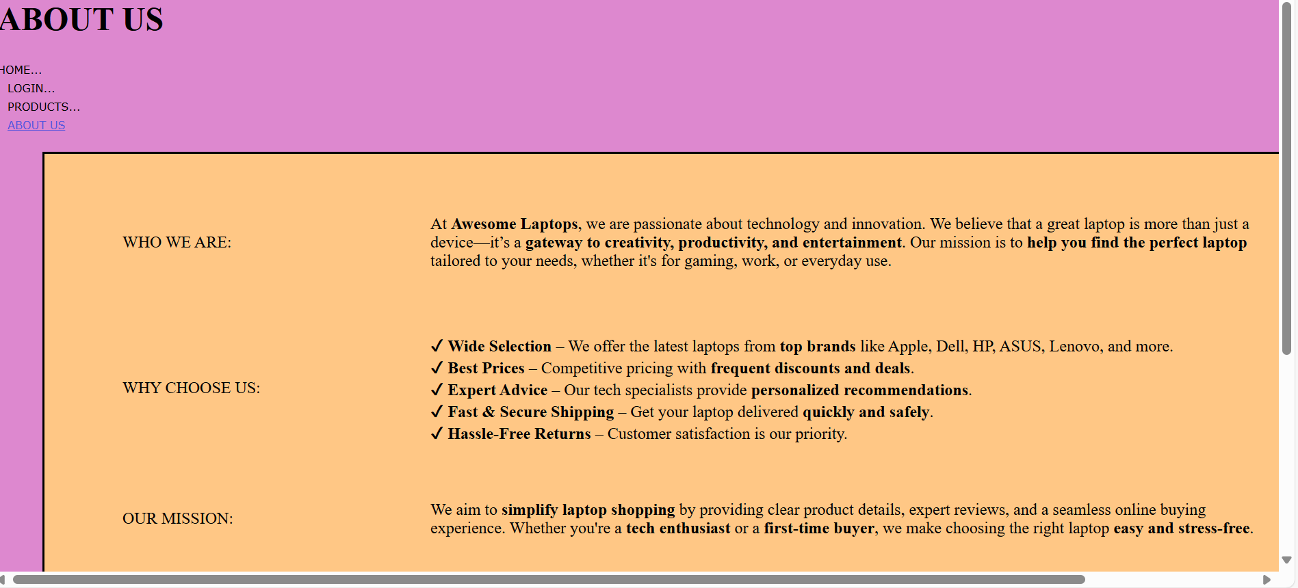

SUB PROGRAM



Web.sitemap:

<?xml version="1.0" encoding="utf-8" ?>

<siteMap xmlns="http://schemas.microsoft.com/AspNet/SiteMap-File-1.0" >

<siteMapNode url="Home.aspx" title="HOME...." description="">

<siteMapNode url="https://erp.psgrkcw.ac.in" title="ERP PORTAL" description="" />

</siteMapNode>

</siteMap>

OUTPUT:

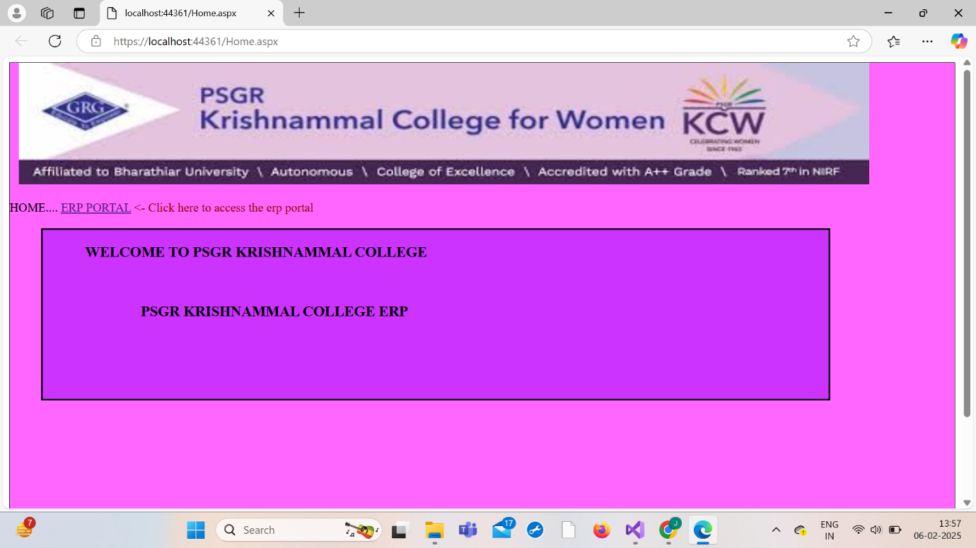

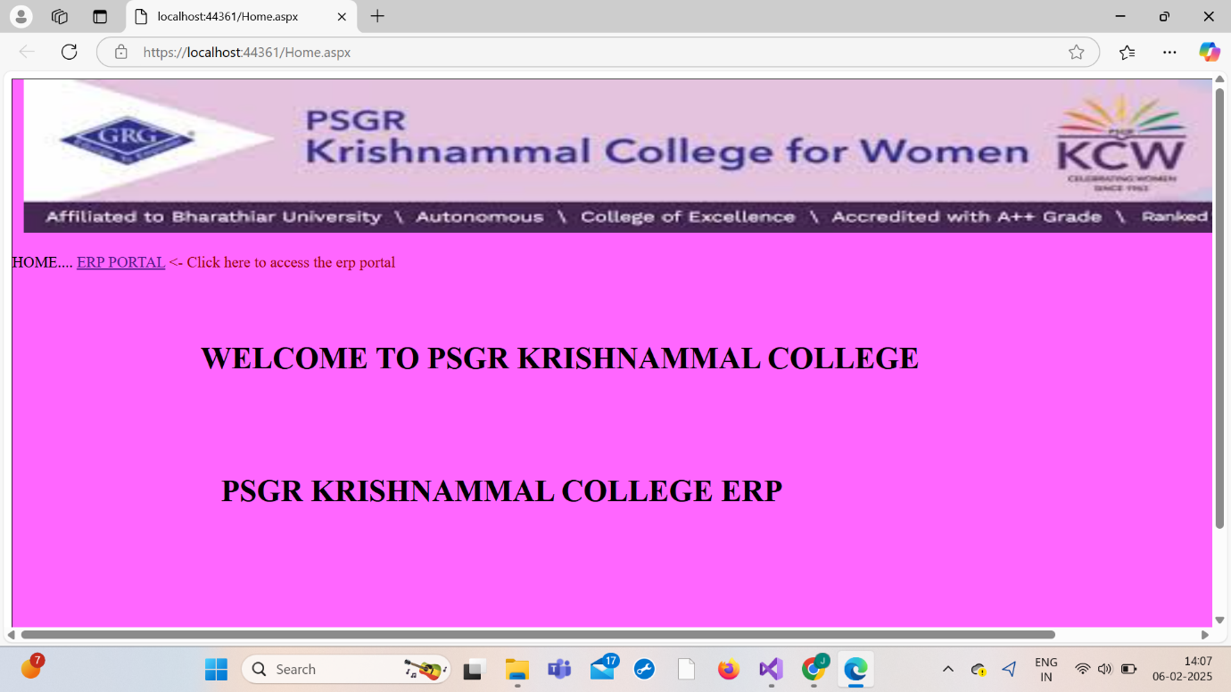



6. Exercise using exception handling

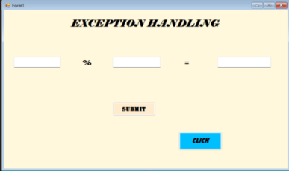

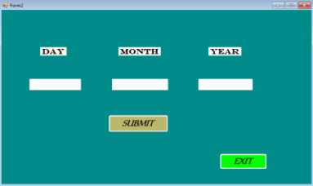

using System;

using System.Collections.Generic;

using System.ComponentModel;

using System.Data;

using System.Drawing;

using System.Linq;

using System.Text;

using System.Threading.Tasks;

using System.Windows.Forms;

namespace WindowsFormsApp10

{

public partial class Form1 : Form

{

public Form1()

{

InitializeComponent();

}

private void button1_Click(object sender, EventArgs e)

{

try

{

int numerator = Convert.ToInt32(textBox1.Text);

int denominator = Convert.ToInt32(textBox2.Text);

int Answer = numerator / denominator;

textBox3.Text = Answer.ToString();

}

catch (FormatException)

{

MessageBox.Show(“Invalid input enter two numbers please”);

}

catch (DivideByZeroException divideByZeroException)

{

MessageBox.Show(divideByZeroException.Message, “Can’t divide by zero”);

}

finally

{

textBox1.Text = “ “ ;

textBox2.Text = “ “ ;

}

}

private void button2_Click(object sender, EventArgs e)

{

var Form2 = new Form2();

Form2.Show();

this.Hide();

}

}

}

using System;

using System.Collections.Generic;

using System.ComponentModel;

using System.Data;

using System.Drawing;

using System.Linq;

using System.Text;

using System.Threading.Tasks;

using System.Windows.Forms;

namespace WindowsFormsApp13

{

public partial class Form2 : Form

{

public Form2()

{

InitializeComponent();

}

public partial class Form2 : Form

{

public Form2()

{

InitializeComponent();

}

private void button2_Click(object sender, EventArgs e)

{

this.Close();

}

private void button1_Click(object sender, EventArgs e)

{

try

{

int day = Convert.ToInt32(Daybox.Text);

int year = Convert.ToInt32(Yearbox.Text);

string month = Monthbox.Text;

}

catch (FormatException)

{

MessageBox.Show("Invalid input, Enter a valid form of date, please! ");

}

finally

{

String date = Convert.ToString(Daybox.Text);

String yr = Convert.ToString(Yearbox.Text);

string month = Monthbox.Text;

MessageBox.Show(date + "/ " +month + "/ "+yr);

Daybox.Text = " " ;

Monthbox.Text =" " ;

Yearbox.Text = " " ;

}

}

}

}

}

OUTPUT:

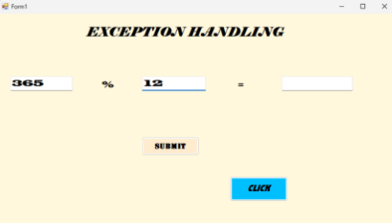

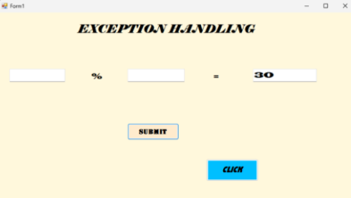

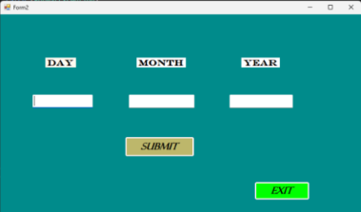

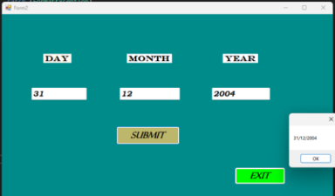

7. Exercise using string operation

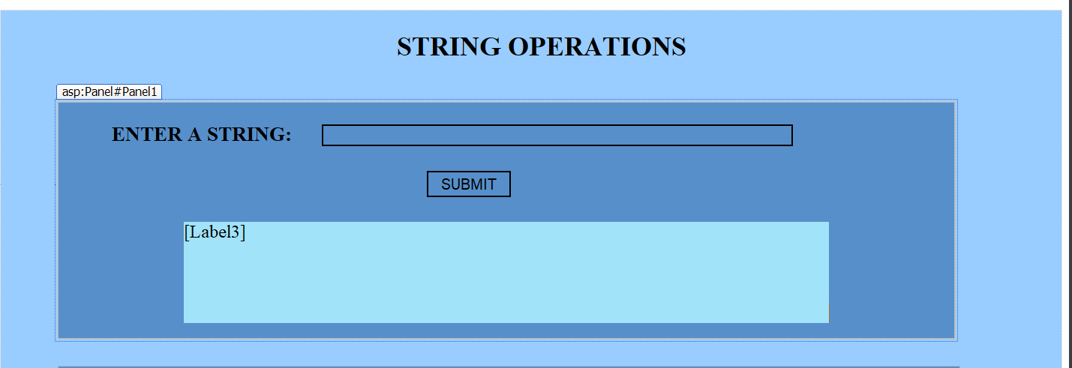

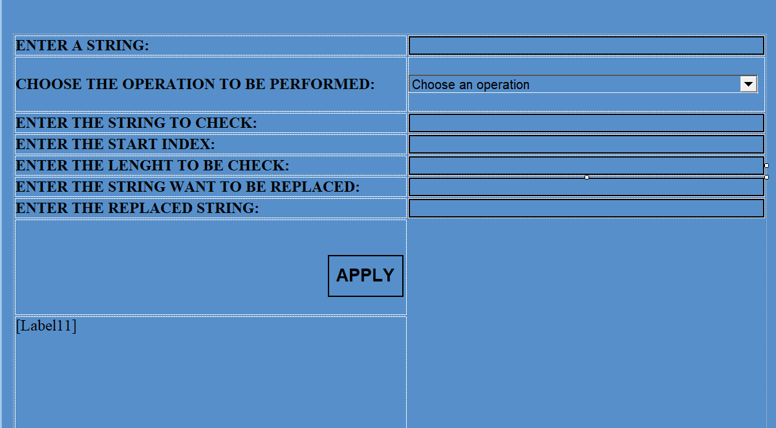

using System;

using System.Collections.Generic;

using System.Linq;

using System.Web;

using System.Web.UI;

using System.Web.UI.WebControls;

namespace WebApplication15

{

public partial class WebForm1 : System.Web.UI.Page

{

protected void Page_Load(object sender, EventArgs e)

{

}

protected void Button1_Click(object sender, EventArgs e)

{

string s = TextBox1.Text;

int num = 0, cl = 0, sl = 0, sp = 0, ss = 0;

foreach (char c in s)

{

if (Char.IsDigit(c)) num++;

else if (Char.IsUpper(c)) cl++;

else if (Char.IsLower(c)) sl++;

else if (Char.IsWhiteSpace(c)) sp++;

else sp++;

}

Label3.Text = $"number of digits:{num}<br/>" + $"capital letters:{cl}<br/>" + $"small letters:{sl}<br/>" + $"spaces:{sp}<br/>" + $"special symbols:{sp++}";

}

protected void Button2_Click(object sender, EventArgs e)

{

string s = TextBox2.Text;

int choice = Convert.ToInt32(DropDownList1.SelectedValue);

string output = "";

switch (choice)

{

case 1:

output = (string)s.Clone();

break;

case 2:

output = s.Contains(TextBox4.Text) ? "True" : "False";

break;

case 3:

output = s.ToLower();

break;

case 4:

output = s.ToUpper();

break;

case 5:

output = s.Trim();

break;

case 6:

int start = int.Parse(TextBox5.Text);

int length = int.Parse(TextBox6.Text);

output = s.Substring(start, length);

break;

case 7:

output = s.Replace(TextBox7.Text, TextBox8.Text);

break;

default:

output = "Invalid choice.";

break;

}

Label11.Text = "Output: " + output;

}

}

}

OUTPUT

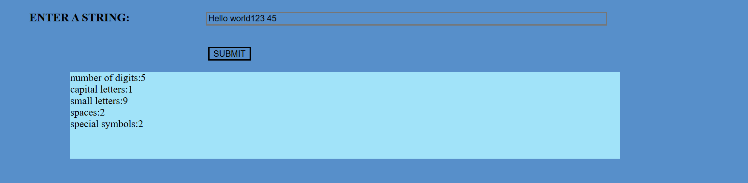

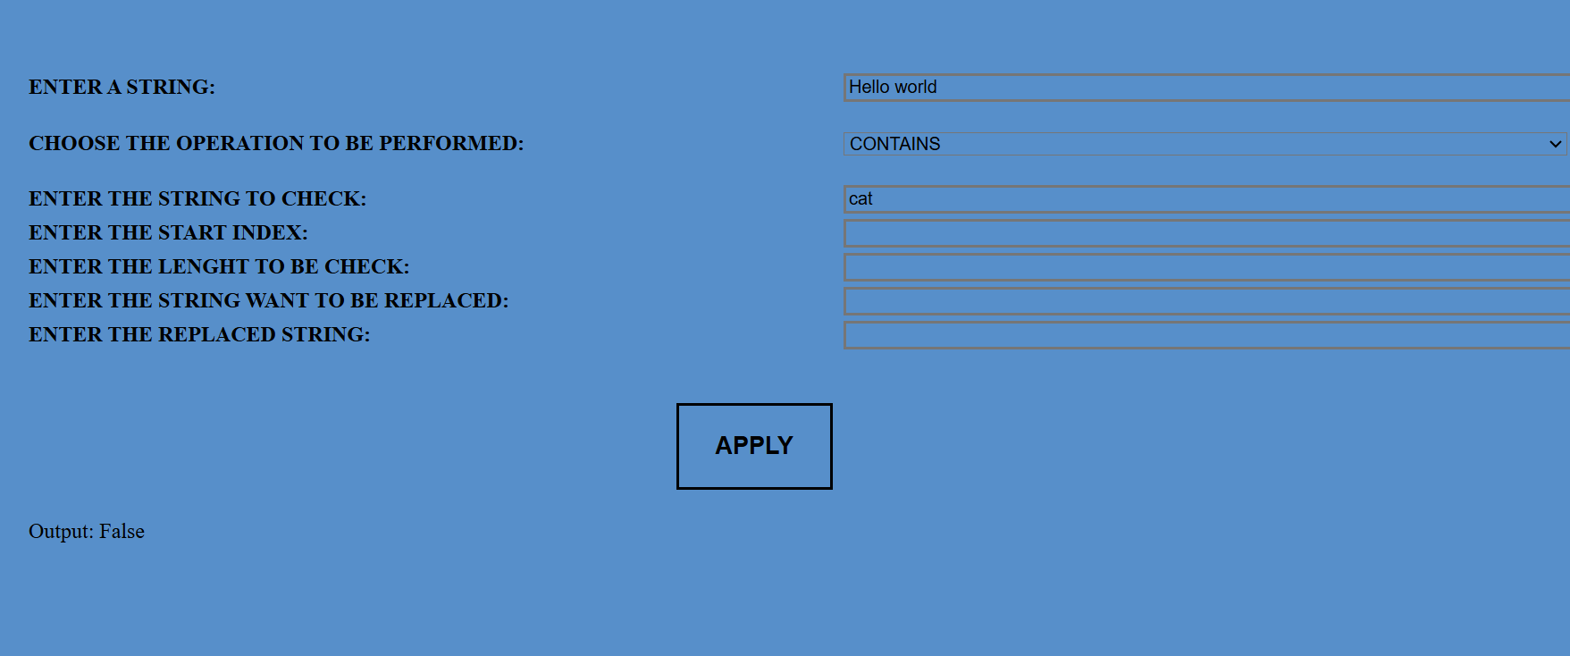

8. Exercise using File operations

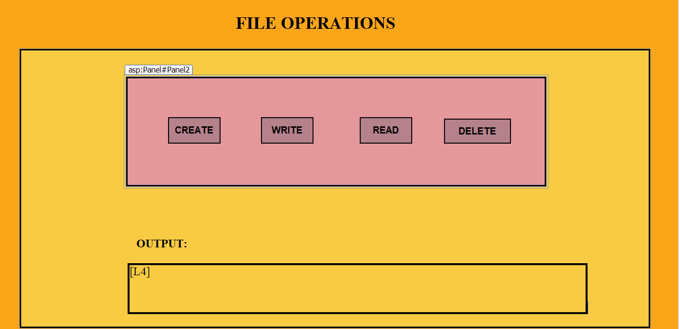

using System;

using System.Collections.Generic;

using System.Linq;

using System.Web;

using System.Web.UI;

using System.Web.UI.WebControls;

using System.IO;

namespace file_operations

{

public partial class WebForm1 : System.Web.UI.Page

{

string filePath => Path.Combine(Environment.GetFolderPath(Environment.SpecialFolder.MyDocuments),"Sample.txt");

protected void Button1_Click(object sender, EventArgs e)

{

try

{

if (!File.Exists(filePath))

{

File.Create(filePath).Close();

L4.Text = "File created successfully.";

}

else

{

L4.Text = "File already exists.";

}

}

catch (Exception ex)

{

L4.Text = "Error: " + ex.Message;

}

}

protected void Write_Click(object sender, EventArgs e)

{

File.WriteAllText(filePath, "Hello, this is a test file.");

L4.Text = "Text written successfully.";

}

protected void Read_Click(object sender, EventArgs e)

{

L4.Text = File.Exists(filePath) ? File.ReadAllText(filePath) : "File not found.";

}

protected void Button1_Click1(object sender, EventArgs e)

{

if (File.Exists(filePath)) { File.Delete(filePath); L4.Text = "File deleted."; }

else L4.Text = "File does not exist.";

}

}

}

